1. Introduction

Goal of the Project
The primary goal of this project was to design, build, and validate a lightweight fixed-wing unmanned aircraft controlled using differential thrust. The project aimed to demonstrate that stable and maneuverable flight can be achieved using only two propulsion motors and a custom-built flight controller, eliminating the need for conventional movable control surfaces.


Project Overview
A foamboard twin-motor RC airplane was designed and assembled as the experimental platform. The aircraft is controlled by varying the thrust of the left and right motors while maintaining fixed aerodynamic surfaces. A custom flight controller based on an ESP8266 microcontroller processes inertial sensor data and executes a handwritten cascaded PID control algorithm to stabilize the aircraft and follow the pilot's commands.
This project integrates embedded systems, wireless communication, sensor fusion, control engineering, and aircraft dynamics into a compact, low-cost experimental platform for studying autonomous flight control concepts.

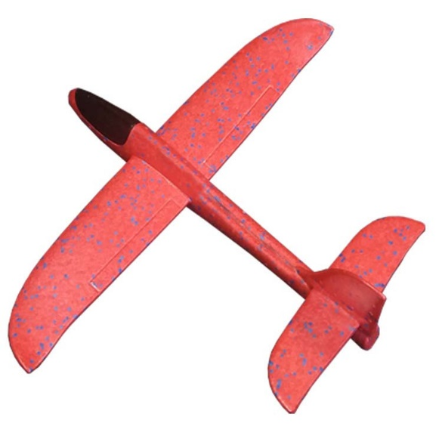
2. Aircraft Platform
The aircraft platform is a lightweight foamboard fixed-wing model assembled from a commercially available kit. It is powered by two brushless DC motors mounted on the wings. Unlike conventional RC airplanes, the elevator and rudder remain fixed during flight, and all maneuvering is achieved by controlling the thrust difference between the left and right motors (differential thrust).

3. Hardware Components

3.1 Flight Controller
The aircraft is controlled by an ESP8266 WeMos D1 Mini microcontroller, which serves as the main onboard processor. The controller receives commands from the ground station, processes sensor measurements, executes the custom flight control algorithm, and generates PWM signals for the motors. All control software was developed specifically for this project and runs directly on the ESP8266.
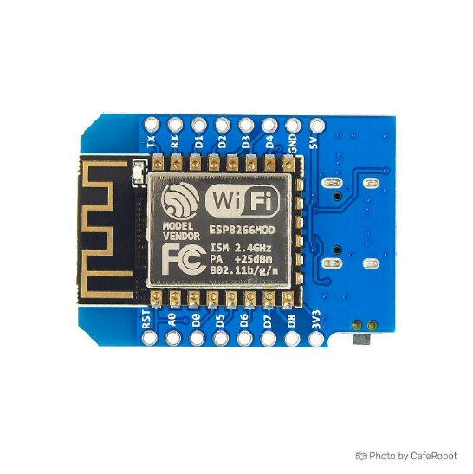
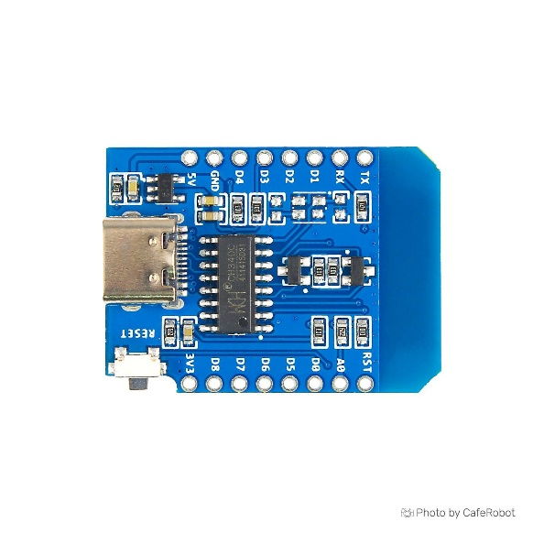

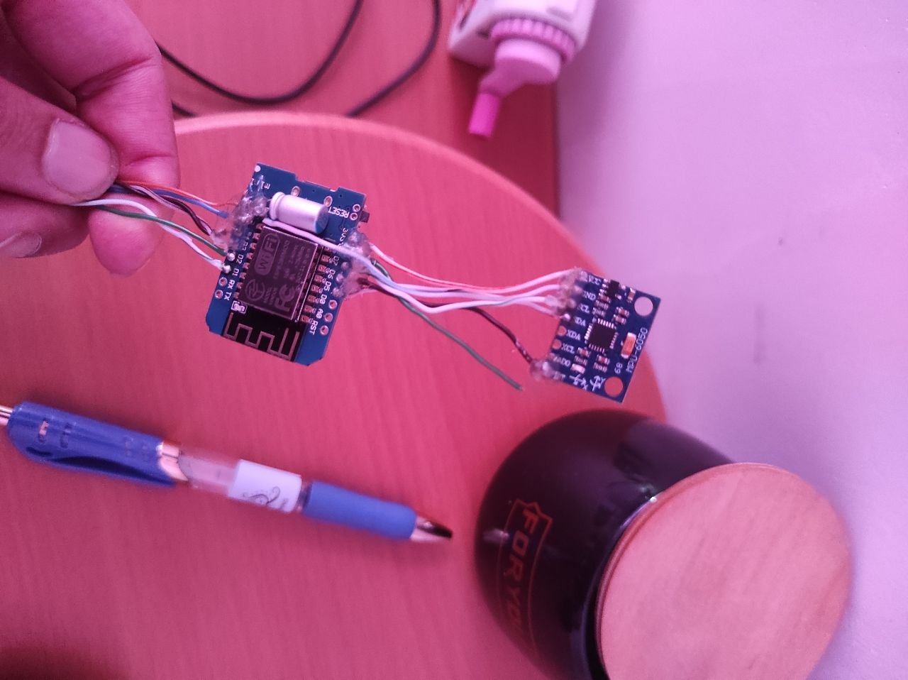
3.2 Inertial Measurement Unit (IMU)
The aircraft uses an MPU6050 inertial measurement unit (IMU) to estimate its attitude during flight. The sensor combines a 3-axis accelerometer and a 3-axis gyroscope, providing real-time measurements of the aircraft's motion. These measurements are processed by the flight controller to estimate the roll angle, which is used as feedback for the cascaded PID controller.

3.3 Power System
The aircraft is powered by a single-cell 3.7 V Lithium-ion battery, selected for its low weight and sufficient energy capacity. A standard commercial Lithium-ion cell was used instead of a high-discharge (high C-rate) battery, demonstrating that the aircraft can operate using inexpensive and readily available components.
Battery Capacity: 300 – 800mAh
Average Flight Time: 25 minuts on 800mAh

3.4 Motor Driver
Two logic-level N-channel MOSFETs drive the coreless DC motors. The ESP8266 controls each motor independently using PWM signals for speed regulation.
MOSFET: SMD IRLML2502 (N-Channel)

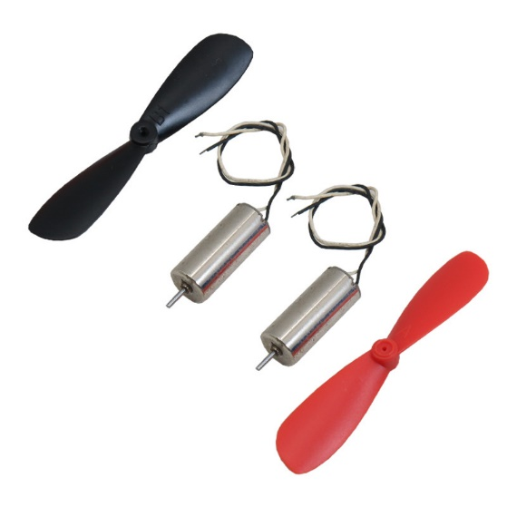
3.5 Propulsion System

The aircraft is equipped with two coreless DC motors mounted symmetrically on the wings. Independent speed control of each motor provides differential thrust, eliminating the need for conventional movable control surfaces while maintaining effective roll control and maneuverability.

4. Communication System

The aircraft uses a two-stage wireless communication system for low-latency and reliable control.
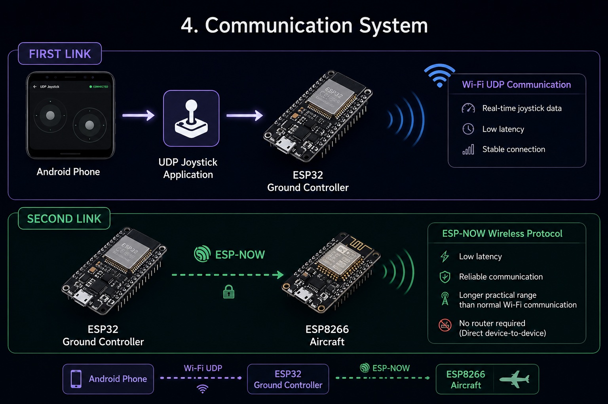

4.1 Smartphone to Ground Station
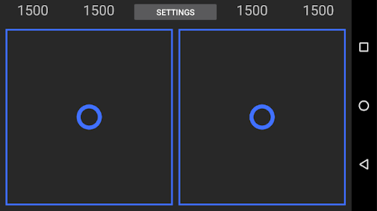
An Android smartphone running a UDP Joystick application sends throttle and roll commands via Wi-Fi (UDP) to an ESP32 ground controller in real time.
Communication Flow
Android Phone → UDP Joystick → Wi-Fi (UDP) → ESP32

4.2 Ground Station to Aircraft
The ESP32 forwards the control commands to the onboard ESP8266 using the ESP-NOW protocol. This direct device-to-device communication provides low latency, does not require a Wi-Fi router, and offers a practical range of approximately 200–300 meters in open areas.
Communication Flow
Android Phone → Wi-Fi (UDP) → ESP32 Ground Station → ESP-NOW → ESP8266 Flight Controller

5. Control Method
Unlike a conventional RC airplane, this aircraft has no ailerons, rudder, or movable elevator. Flight control is achieved only by independently controlling the thrust of the left and right motors.
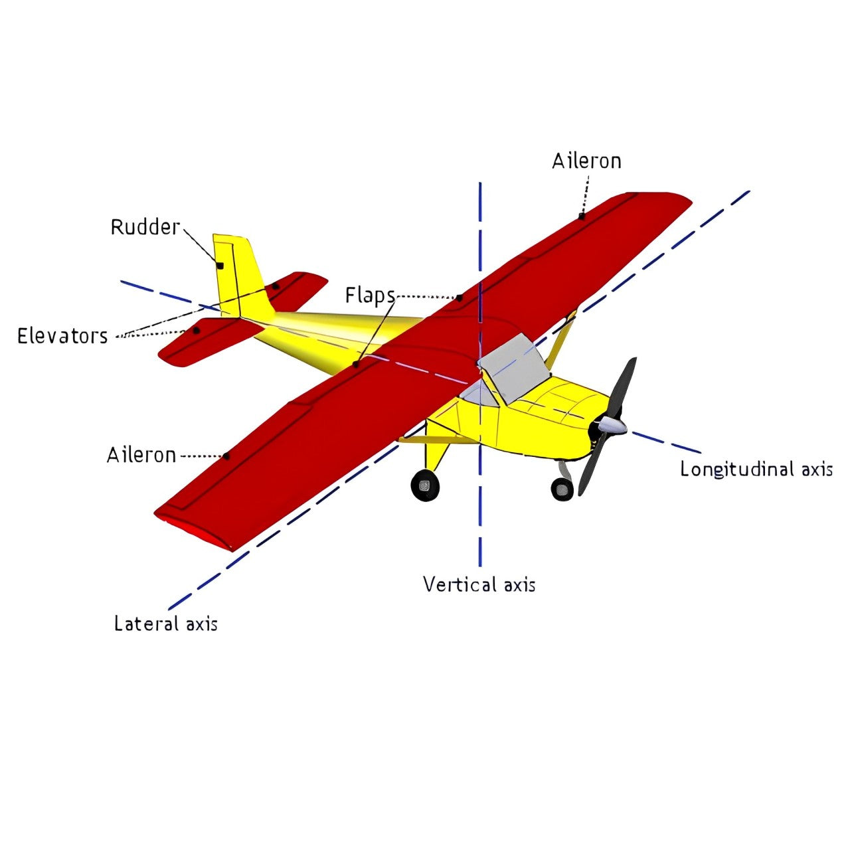
The pilot provides only two commands: throttle and desired roll angle. A custom flight controller converts these inputs into the required motor speeds, enabling stable flight using differential thrust.

Conventional RC Airplane

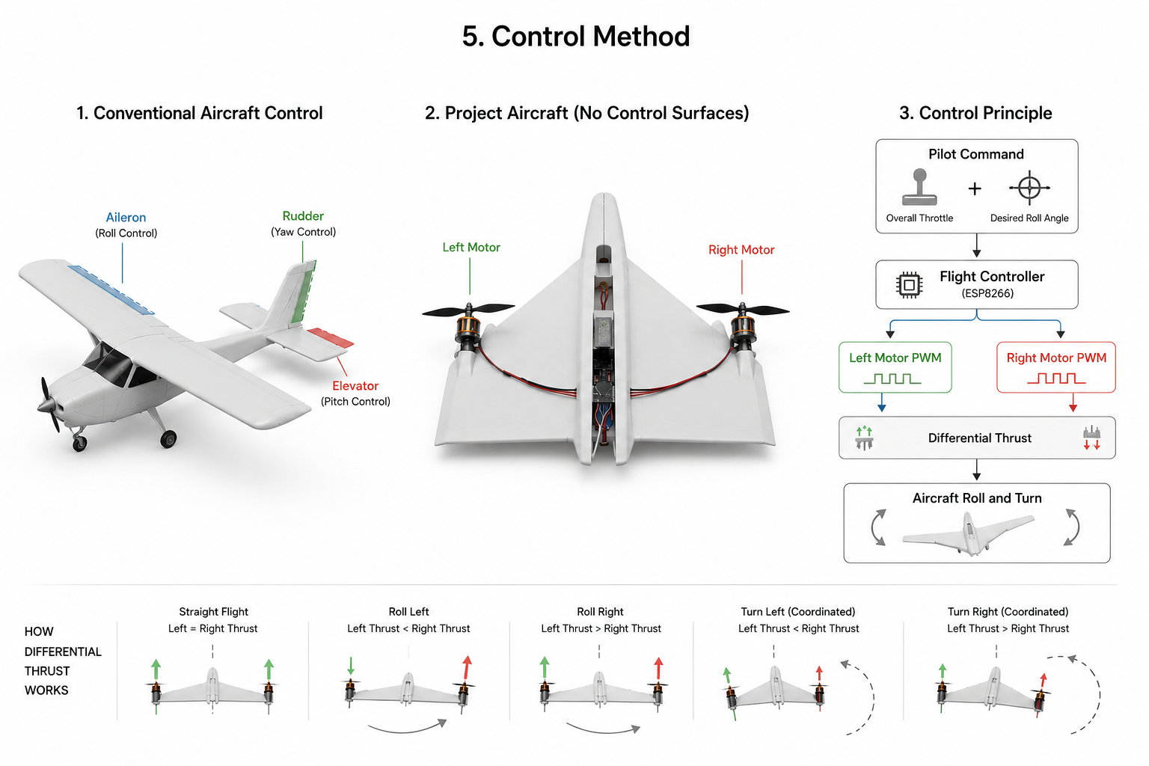

Control Diagram
Throttle + Desired Roll Angle
↓
ESP8266 Flight Controller
↓
Left & Right Motor PWM
↓
Aircraft Motion

6. Flight Control Algorithm

The flight control algorithm was fully developed from scratch using a cascaded PID controller running on the ESP8266, converting the pilot’s desired roll angle into differential motor thrust for aircraft stabilization. Control Flow: Pilot Input → Desired Roll Angle → Outer PID → Inner PID → Motor Thrust → Aircraft Roll

7. Performance
The aircraft was tested to evaluate flight stability, communication reliability, and system performance. The final prototype achieved approximately 25 minutes of flight time, a 200 m communication range, and a total weight of 100 g. The MPU6050 IMU was used for attitude estimation, with the controller supporting a maximum roll command range of ±40°. The custom PID control system provided stable differential thrust control using the two-motor configuration.
Measured Parameters
- Flight time: ~25 minutes
- Communication range (ESP-NOW): ~200 m
- IMU sensor: MPU6050 (accelerometer + gyroscope)
- Maximum roll angle: ±40°
- Battery life: ~25 minutes
- Total aircraft weight: 100 g

